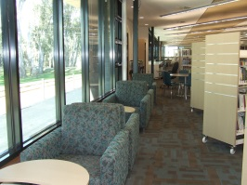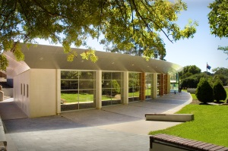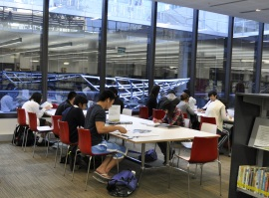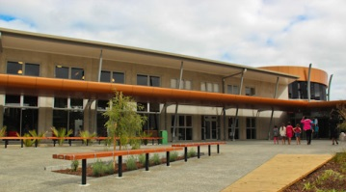

***BY DESIGN:***

***PUBLIC LIBRARY PLACES AND SPACES IN AUSTRALIA AND NEW ZEALAND***

**a conference for local government, public librarians, directors of community services, architects, interior designers, library suppliers, and others who seek to provide better public library places and spaces for all in their communities**

This ninth of the highly rated annual Auslib conferences will help public library decision makers in Australia and New Zealand to plan for new and redeveloped library places and spaces in the context of their growing valuation as the community’s third place after home and school or work, and as centres for community connection, reading, learning and creativity

**Program**

***By Design*** will have a tightly focused program of 20 *international, Australian and New Zealand speakers*, two Q&A panel sessions, targeted recommendations, and an information folder including a copy of the new edition of *People places: a guide for public library buildings in NSW*. It will explore

* the diversity of the roles and services of today’s and future public libraries
* the implications of this for the public library’s location, accessibility, spaces and places
* innovation and best practice in public library location, architecture, interior design, technology and facilities

**When**

* *optional half day preconference study tour of newer public libraries in Sydney hosted by the State Library of NSW* **Wednesday 13 November 2013** 12noon-5.00pm
* *conference*  **Thursday 14 November – Friday 15 November 2013**
* *optional half day postconference workshop* ‘Customer centred library design’conducted by Rachel Van Riel, Director of the UK’s Opening the Book Ltd , **Saturday 16 November 2013** 9.00am-1.00pm

**Where**

State Library of NSW Macquarie Street Sydney NSW. There are numerous hotels within walking distance

**Registration includes**

* coffee on arrival, morning and afternoon teas, lunches
* conference reception (drinks and finger food) 5.30-7.30pm Thursday 14 November
* speaker powerpoints
* information folder on public library design and buildings
* full printed conference proceedings
* certificate of attendance

**The registration form is on the back of this sheet** **and is also available at www.auslib.com.au**. The closing date for registration is **Friday 11 October 2013.** Early registration is recommended, particularly if you wish to join the preconference study tour and the postconference workshop

**The provisional conference program will be available at www.auslib.com.au from 1 May 2013**

***Conference enquiries***

Judith Bundy tel 08 8278 4363 international 61 8 8278 4363 info@auslib.com.au

***Study tour/NSW public libraries enquiries***

Leanne Perry/Ellen Forsyth tel 02 92731523 lperry@sl.nsw.gov.au

***BY DESIGN: PUBLIC LIBRARY PLACES AND SPACES***

**14-15 November 2013**

Metcalfe Auditorium State Library of NSW

Macquarie Street Sydney NSW

**Registration form and Tax invoice**

ABN 89 680 150 211

***Please keep a copy of this form as your tax invoice***

*Single day registrations are not available but a split registration for two delegates only from one organisation will be accepted – please indicate* ***both*** *names on this form*

**Personal details**  *Please print clearly*

Title First name Surname

Preferred name on name badge

***Second delegate for split registration***

Title First name Surname

Preferred name on name badge

Organisation

Mailing address

City State/NZ Postcode

Email Tel ( )

Please specify any special needs, including dietary

**Conference fee**

Registration fee – *includes morning and afternoon teas, lunches, conference reception, full proceedings, information folder, speaker powerpoints and certificate of attendance* : A$770.00 A$

Additional guest/s for conference reception 14 November : A$33.00 per person A$

Optional half day preconference library study tour, Wednesday 13 November: A$44.00 A$

Optional half day postconference workshop with Rachel Van Riel, Sat. 16 November: A$66.00 A$

**Total payment A$**

**Refund policy: 30 days or more before the conference 75% of fee refunded; 29-14 days before the conference 50% of fee refunded; 13-7 days before the conference 25% of the fee refunded; 0-6 days before the conference 0% refunded**

**Payment details**

Cheque (in Australian dollars) enclosed ❒ made payable to Auslib Press Pty Ltd

**OR** Payment has been made by EFT ❒

Account name: Auslib Press Pty Ltd BSB: 085-142 Number: 62891-3462 (for international transfers BIC/SWIFT: NATAAU 3303M)

**OR** Payment will be made by ….…/….…/2013

**OR** Charge to credit card: Visa ❒ Mastercard ❒

Credit card number Expiry date

Cardholder name

Signature Amount A$

**MAIL, FAX OR EMAIL THE REGISTRATION FORM TO ARRIVE BY FRIDAY 11 OCTOBER 2013** **TO**

Auslib Press Pty Ltd

PO Box 622 Blackwood South Australia 5051

**fax 08 8278 4000 international +61 8 8278 4000 email info@auslib.com.au**