***BEYOND THE WALLS***

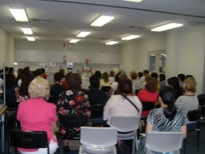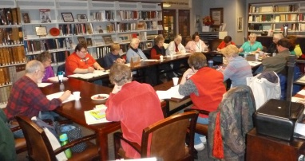

***PUBLIC LIBRARIES IN AUSTRALIA AND NEW ZEALAND ENGAGING THEIR COMMUNITIES***

**a conference for local government leaders, directors of community services, public librarians and others, about the unique capacity and potential of public libraries to foster and support community capacity building, civic engagement, and wellbeing**

**Program**

This tenth of the highly rated annual Auslib thematic conferences will have a tightly focused program of 20 *international, Australian and New Zealand speakers*, two Q&A panel sessions, targeted recommendations, and an information folder. It will explore

* the diversity of current public library outreach
* innovation and best practice in public library outreach – from supporting player to community engagement leader
* creating permeable walls between the library as place and space, and today’s diverse and complex communities.

**When**

* *optional full day preconference study tour of newer public libraries in the Adelaide region*  **Wednesday 25 March 2015** 9am-5.00pm
* *conference*  **Thursday 26 March – Friday 27 March 2015**

**Where**

Mercure Grosvenor Hotel, North Terrace, Adelaide, South Australia. This is in the centre of the Adelaide CBD, opposite Parliament House

**Registration includes**

* coffee on arrival, morning and afternoon teas, lunches
* conference reception (drinks and finger food) 5.30-7.30pm Thursday 26 March
* speaker powerpoints
* information folder
* full printed conference proceedings
* certificate of attendance

**The registration form is on the back of this sheet** **and is also available at www.auslib.com.au**. The closing date for registration is **Friday 6 March 2015.** Early registration is recommended, particularly if you wish to join the preconference study tour (60 only places available)

**The provisional conference program will be available at www.auslib.com.au by 1 November 2014**

***Conference and study tour enquiries***

Judith Bundy tel 08 8278 4363 international 61 8 8278 4363 info@auslib.com.au

***BEYOND THE WALLS: PUBLIC LIBRARIES IN AUSTRALIA AND NEW ZEALAND ENGAGING THEIR COMMUNITIES***

**26 – 27 March 2015**

Mercure Grovesnor Hotel

North Terrace, Adelaide, South Australia

**Registration form and Tax invoice**

ABN 89 680 150 211

***Please keep a copy of this form as your tax invoice***

*Single day registrations are not available but a split registration for two delegates only from one organisation will be accepted – please indicate* ***both*** *names on this form*

**Personal details**  *Please print clearly*

Title First name Surname

Preferred name on name badge

***Second delegate for split registration***

Title First name Surname

Preferred name on name badge

Organisation

Mailing address

City State/NZ Postcode

Email Tel ( )

Please specify any special needs, including dietary

**Conference fee**

Registration fee – *includes morning and afternoon teas, lunches, conference reception, full proceedings, information folder, speaker powerpoints and certificate of attendance* : A$880.00 A$

Additional guest/s for conference reception 26 March : A$40.00 per person A$

Optional full day preconference library study tour, Wednesday 25 March: A$88.00 A$

(this will be refunded if tour is full)

**Total payment A$**

**Refund policy: 30 days or more before the conference 75% of fee refunded; 29-14 days before the conference 50% of fee refunded; 13-7 days before the conference 25% of the fee refunded; 0-6 days before the conference 0% refunded**

**Payment details**

Cheque (in Australian dollars) enclosed ❒ made payable to Auslib Press Pty Ltd

**OR** Payment has been made by EFT ❒

Account name: Auslib Press Pty Ltd BSB: 085-142 Number: 62891-3462 (for international transfers BIC/SWIFT: NATAAU 3303M)

**OR** Payment will be made by ….…/….…/201

**OR** Charge to credit card: Visa ❒ Mastercard ❒

Credit card number Expiry date

Cardholder name

Signature Amount A$

**MAIL, FAX OR EMAIL THE REGISTRATION FORM TO ARRIVE BY FRIDAY 6 MARCH 2015** **TO**

Auslib Press Pty Ltd

PO Box 622 Blackwood South Australia 5051

**fax 08 8278 4000 international +61 8 8278 4000 email info@auslib.com.au**